Light Bulb Conundrum
I recently went to the store to purchase light bulbs. The options were a bit overwhelming. Do I buy standard bulbs (incandescent) or energy efficient ones? If I buy energy efficient ones, which kind: LED or Compact Fluorescent (CFL)?

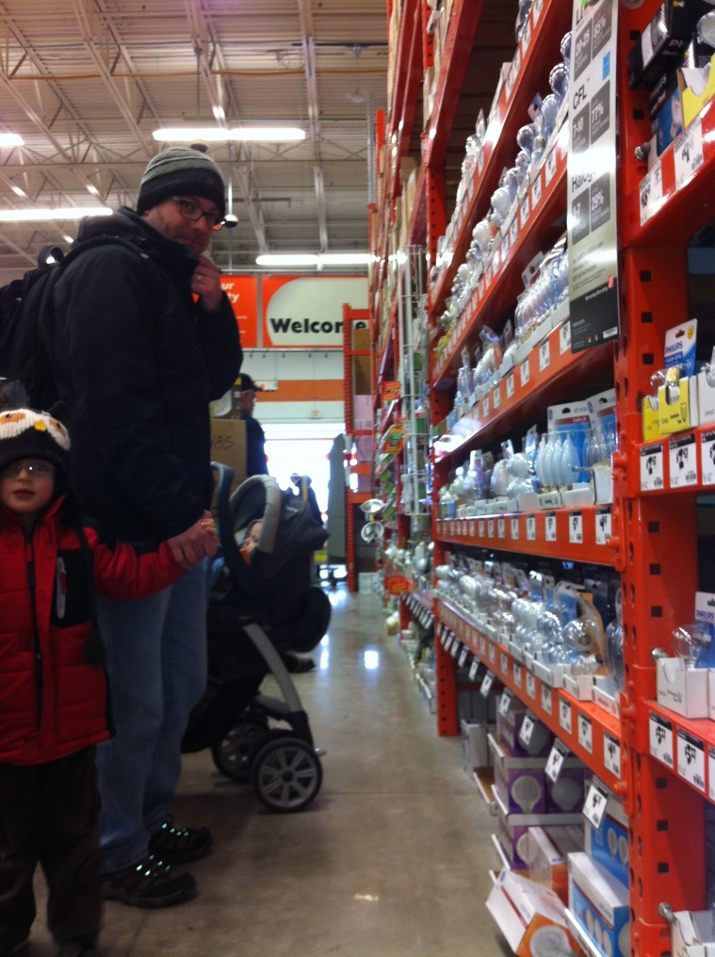

Money is a bit tight right now; I can’t spend extra money on every bulb in my house—there’s like 60 of them—just to make myself feel like I’m doing my part to combat climate change. Based on cost-effectiveness, make a decision about which bulb you think I should buy.

Background info: Yearly costs for all light bulbs are based off the same ideal usage of 3 hours per day with electricity costing 11cents per kilowatt-hour.
Below are the best-looking options to me from Home Depot’s website. I arranged the categories in alphabetical order. Just because.

Compact Fluorescent (CFL)
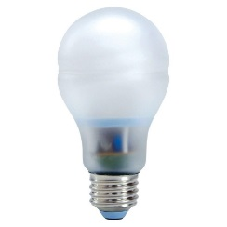  GE Reveal 15-Watt (60W) Bright from the Start CFL Light Bulb  (2-Pack) | - Estimated yearly energy cost: $1.81  - Average Life: 8,000 hours (7.3 years) | $13.97 / package
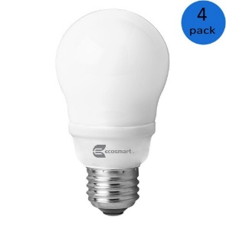  EcoSmart 14-Watt (60W) A19 Bright White CFL Light Bulb (4-Pack) | - Estimated yearly energy cost: $1.69  - Average Life: 8,000 hours (7.3 years) | $15.94 / package

Incandescent:
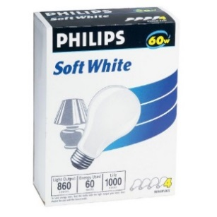  Philips 60-Watt Household Incandescent Light Bulb  (4-Pack) | - Estimated Yearly Energy Cost: $7.23  - Average Life: 1,000 hours (0.9 years) | $1.47 / package
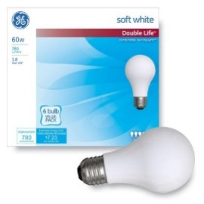  GE Double Life 60-Watt A19 Soft White General Purpose Incandescent Light Bulb  (6-Pack) | - Estimated Yearly Energy Cost: $7.23  - Average life: 2,000 hours (1.8 years) | $3.97 / package

Light-Emitting Diode (LED)
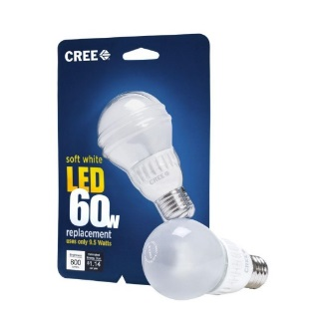  Cree 9.5-Watt (60W) Soft White (2700k) Dimmable LED Light Bulb | - Estimated yearly energy cost: $1.14  - Average Life: 25,000 hours (22.8 years) | $12.97 / each
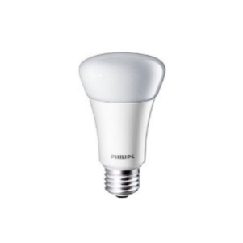  Philips 11-Watt (60W) A19 Household Soft White (2700K) Dimmable LED Light Bulb  (2-Pack) | - Estimated yearly energy cost: $1.32  - Average Life: 25,000 hours (22.8 years) | $29.94 / package
Directions:
- Find the “best” bulb in each category. Be sure to include an explanation I can use to convince my wife—math and all.

Compact Fluorescent (CFL)

Incandescent

Light-Emitting Diode (LED)

- Depending on which incandescent you chose, you may have to buy a new bulb every 0.9 years. That’s very different than buying a light bulb every 22.8 years (crazy LEDs). How do you suggest tackling the problem of having to buy new bulbs when comparing between the categories?

- Now that we know the best bulb in each category and we have an idea about how to include buying new bulbs in our decision-making process, let’s take the next step and compare the best bulbs with each other. Write up a plan of attack for how you might go about comparing the bulbs.

- Now let’s work the plan! Which is the most cost-effective bulb in the long run? Be sure to show your reasoning and thought process.

- What if I only plan to live in my house for 3 years, would your recommendation for the “best” bulb change? Why or why not?

- Is there a magic number of years (or hours of usage) I could plan to stay in my house to make each type of bulb the cheapest? Try to find one.

  - How many years do you need to use the bulb(s) to make Compact Fluorescent bulbs (CFLs) the cheapest?

  - How many years do you need to use the bulb(s) to make Incandescent bulbs the cheapest?

  - How many years do you need to use the bulb(s) to make Light Emitting Diodes (LEDs) the cheapest?

