Say you wanted to tile a cafeteria with a checkered border two tiles deep. The checkered border will alternate between white and colored tiles. The center of the cafeteria will contain only white tiles. We want to know how many of each tile there are in a cafeteria with 100 by 100 tiles INSIDE of the checkered border. This means the cafeteria will be 104 tiles wide each way.
Sometimes it’s easier to figure this out using simpler versions of the same problem and looking for a pattern.
2nd iteration—Checkered border with INSIDE of 2x2
1st iteration—Checkered border with INSIDE of 1x1 tile
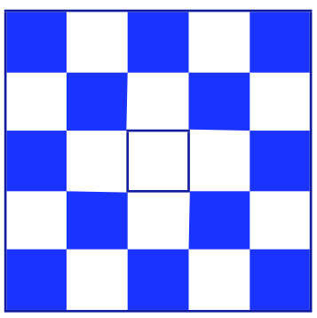
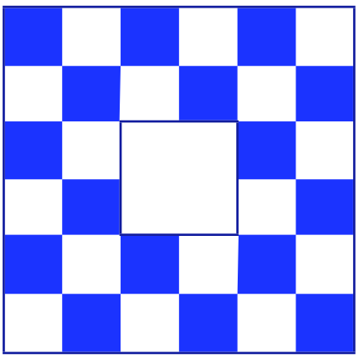

1. Draw the 3rd iteration—Checkered border with INSIDE of 3x3
2. Draw the 4th iteration—Checkered border with INSIDE of 4x4

3. How many colored tiles are there in the 20th iteration of this pattern?
(20 by 20 white tiles in the center)

4. How many colored tiles are there in the 100th iteration?
(100 by 100 white tiles in the center)

5. How many white tiles are there in the 100th iteration? This includes both the white tiles in the checkered border AND the tiles inside the center of the cafeteria.

6. In the tile patterns we’ve looked at, each tile is 1 square foot. White tiles cost $3.19/Sq. Ft. Colored tiles cost $3.45/Sq. Ft. What will it cost to tile the entire 100th iteration?

