Unit 6, Lesson 2
Student Resource 2

Major Millennial Views
1. Dispensational Premillennialism (Extreme Futurists)

Premillennialism: The Second Coming ("parousia”) of Jesus will occur before ("pre-H) a literal, thousand year reign of Christ on the earth.

Dispensational: All of human history is divided into seven dispensations ("a period of time during which man is tested in respect to his obedience to some specific revelation” [New Schofield Bible, 3]). The millennium is the seventh and last dispensation of human history, and will take place between the Second Coming and the Final Judgment.

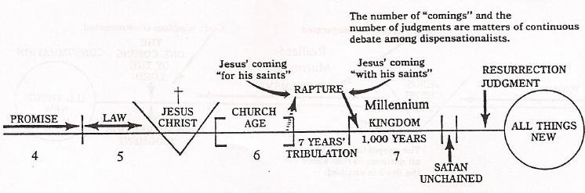

2. Historic Premillennialism (Moderate Futurists)

Premillennialism: The Second Coming ("parousia”) of Jesus will occur before ("pre-") a literal, thousand year reign of Christ on the earth (a few historic premillennialists allow for the possibility that the time frame of a thousand years need not be taken literally).

Historic: In contrast to the views of Dispensational Premillennialism which date to the late 18th century (John N. Darby, Cyrus 1. Schofield), this more moderate view of premillennialism dates back to some of the early church fathers and thus represents a more "historic" premillennial position.



3. Promillennialism/AmiIlennialism/Realized Millennialism

Amillennialism: There is no ("a-") literal, thousand year reign of Christ on earth. The millennium is a figurative term used to describe the period of time between the first coming of Jesus (or a time within Jesus' earthly ministry) and the Second Coming of Jesus. Consequently, the Second Coming of Jesus will occur after the millennium-an age that is currently in the process of being realized.

Realized Millennialism: The term "amillennialism” (literally meaning "no millennium") is unfortunate because it potentially leads to two misguided notions about amillennialists: (1) that they do not believe in the millennium, and (2) that they, therefore, reject the teaching of Revelation 20-- a passage that clearly makes reference to the millennium. Since amillennialists believe that the millennium of Revelation 20 is not exclusively future but is currently in the process of realization, a more accurate term to describe this position might be "realized millennialismlf (this expression was apparently first proposed by Jay Adams, The Time is at Hand [Philadelphia: Presbyterian and Reformed, 1970] 7-11).
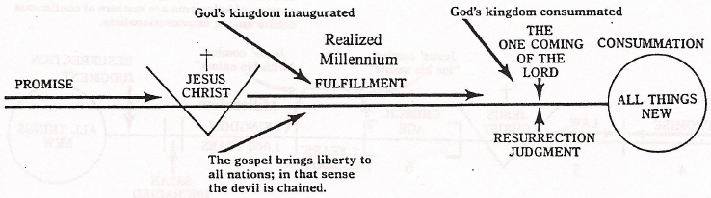

4. Postmillennialism

The Second Coming of Jesus will occur after ("post-“) the millennium--a specific period of peace and righteousness at the end of this present age. In contrast with the amillennial position, the millennium has not yet begun but will be a distinct period of blessedness at the end of ordinary history during which the world will be Christianized through the preaching of the gospel and through the ordinary-but unusually blessed--work of the Holy Spirit.

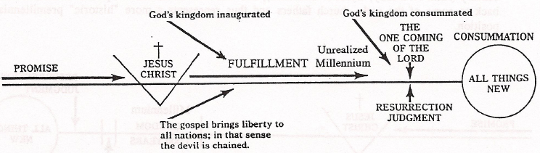

A Glossary for
The Last Days
Apocalypse 1: a better name for the book of Revelation 2: a special kind of literature, Jewish and biblical, that describes the end of the world
Millennium: one thousand years (Latin); see Revelation 20 Millennialists: those who believe in a literal one thousand years of peace on earth
Premillennialism (or: premil): the belief that the Lord will come before the start of the millennium
Amillennialism (or: amil): the belief that there will be no literal one-thousand-year reign of Christ on earth
Postmillennialism (or: postmil): the belief that the Lord will come after a thousand years of peace and prosperity
Dispensation: a period of time in the history of redemption; the Old Testament and the New Testament periods are two different disensations
Dispensationalism: the teaching (of the Scofield Bible) that divides Bible history into seven dispensations, the last of which is the millennium
Rapture (Greek for "snatching away") 1: the living saints will be "raptured" when the Lord returns (1 Thess. 4:17) 2: ecstasy
Tribulation: a period of time in which the faithful are persecuted; in particular, a seven-year period at the end of time, according to the premillennial scheme
Pre-tribulationists: premillennialists who say that Christians will be removed from the earth before the great outpouring of wrath comes to the earth
Mid-tribulationists: premillennialists who say that the Christians will be removed midway through the great seven-year period of tribution
Post-tribulationists: those who say that the church will be removed after the period of trouble and wrath
Parousia (Greek for "coming"): usually, the return of the Lord
Armageddon: the place of the last decisive battle (Rev. 16:16); in the system of the premillennialists, it is a final slaughter on the plains of Jezreel, where the nations will kill each other until Christ intervenes
Eschatology: the doctrine of the last things; eschaton is the Greek word for "last"



