f(x)=5(1.5)^{x} | g(x)=5(0.2)^{x}
p(x)=2(.97)^{x}+3 | Function starts at 1.5 with 50% decay
h(x)=1.5(2)^{x} | Function starts at 5 with 50% growth
x -2 -1 0 1 2  y -125 25 5 1 0.2 | j(x)=5(1.15)^{x}
Function starts at 5 with 80% decay | k(x)=1.5(0.5)^{x}
Function starts at 1.5 with 100% growth | x -2 -1 0 1 2  y -0.889 -1.33 -2 -3 -4.5
m(x)=5(0.8)^{x} | Function starts at 5 with 15% growth
x -2 -1 0 1 2  y 3.78 4.348 5 5.75 6.6125 | Function starts at 5 with 1.5% growth
n(x)=5(1.015)^{x} | q(x)=-2(1.5)^{x}
x -2 -1 0 1 2  y 5.126 5.062 5 4.94 4.882 | Function starts at 5 with 20% decay
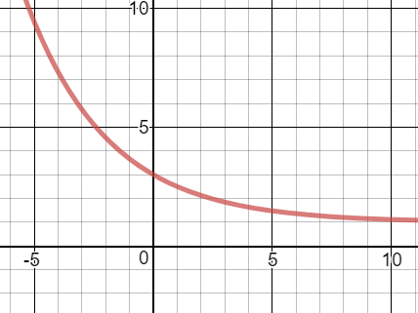 | 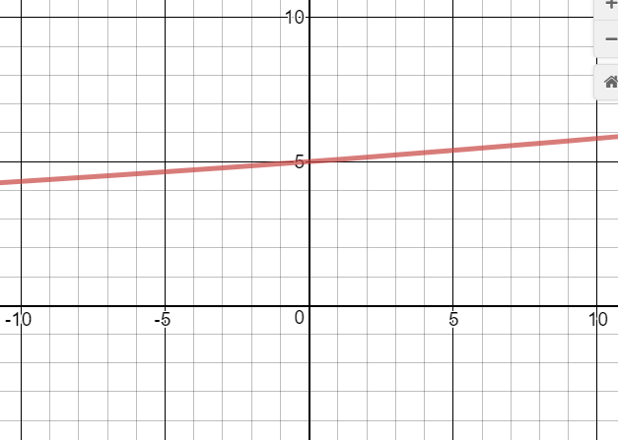
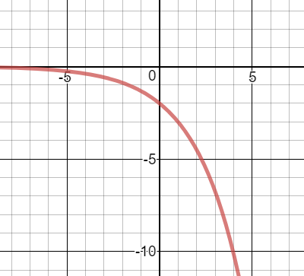 | 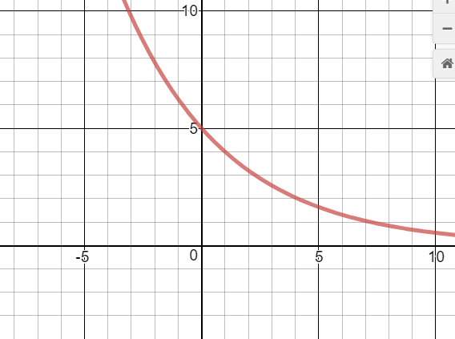
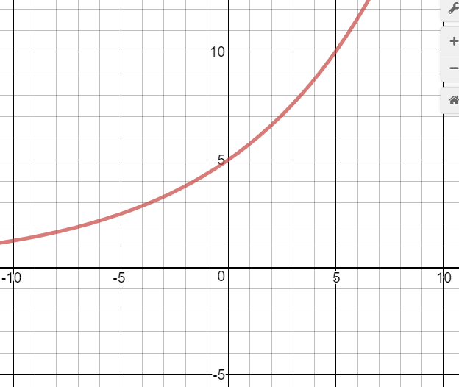 | 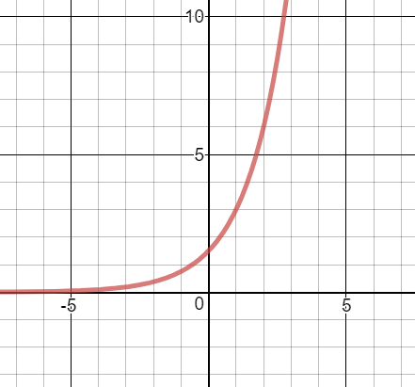
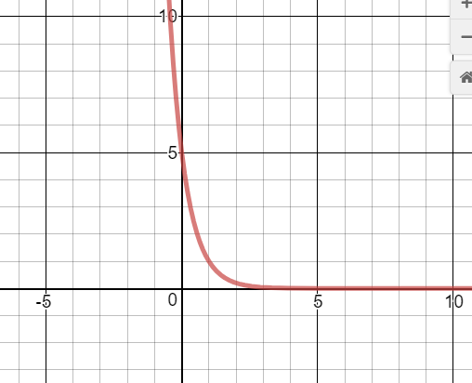 | 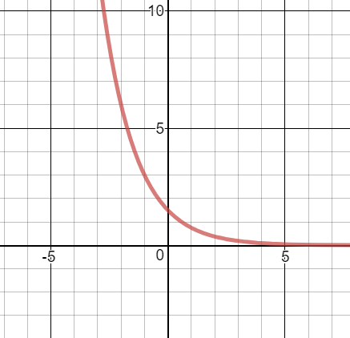
 | 