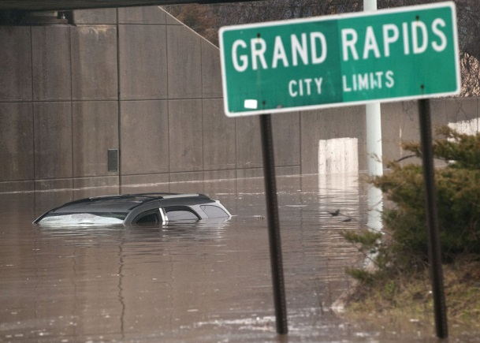
On Sunday, April 21st, 2013 at about 10pm the Grand River, which runs through downtown Grand Rapids, crested at 21.85 feet and started to recede. Flood stage for the river is 18 feet.

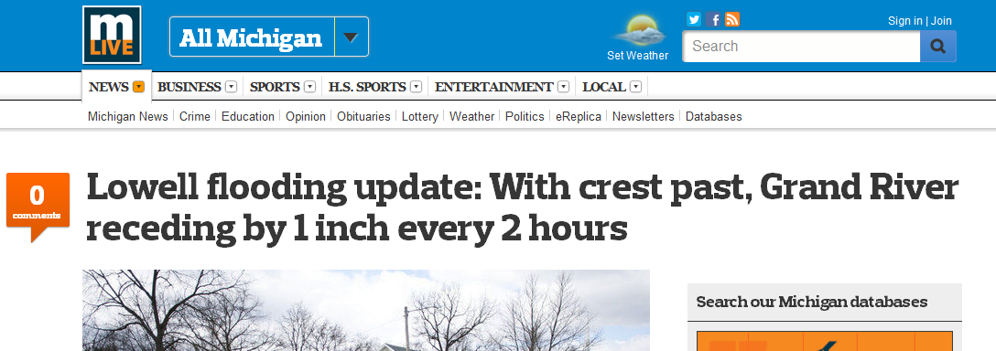
Photo from: http:// www.mlive.com/news/grand-
rapids/index.ssf/2013/04/
must_see_photos_
from_historic.html

Based on this information, when will the river be below flood stage?

