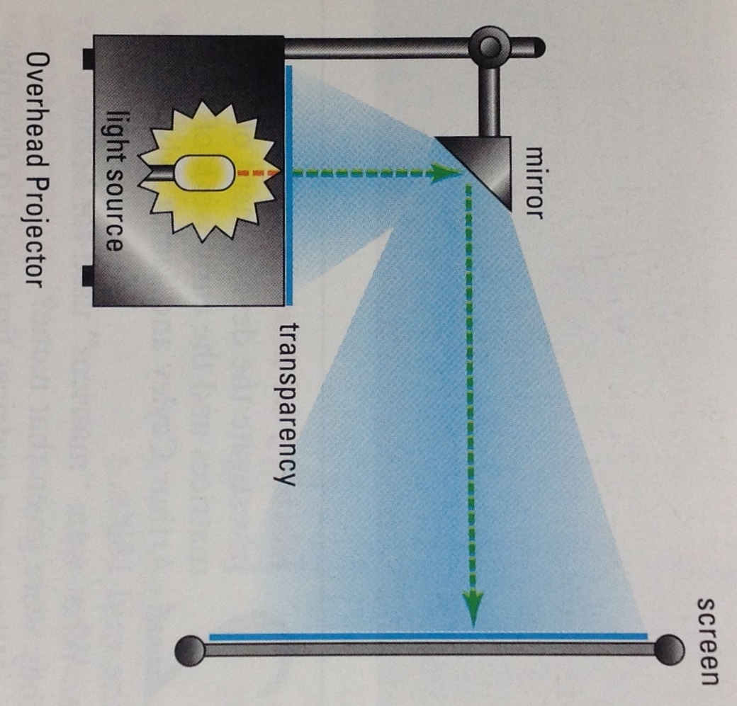Overhead projectors are quite helpful at enlarging images (not so much for making things smaller). Here’s how it works: a light source passes through a transparency (pre-image), reflects off the mirror and projects a picture onto a screen (image).
Here’s what I wonder: Is there a way to predict the size of the image based on the distance of the mirror to the screen? Does the distance between the object and the mirror matter? If so, how?
- Choose an object you can measure at least 4 different ways. You can use overhead transparencies with lines on them, blocks or whatever else you can find (within reason). Measure it in centimeters.
m1: m2: m3: m4:
- Set the distance from the mirror to the screen at 1 meter. Record each of your measurements for the image.
m1’: m2’: m3’: m4’:
- Find a size change matrix, $S_{a}=\left[\begin{matrix}a & 0 \\ 0 & a\end{matrix}\right],$ which will map your preimage (object) measurements onto your image (projection) measurements:
$$\left[\begin{matrix}a & 0 \\ 0 & a\end{matrix}\right]\left[\begin{matrix}m1 & m2 \\ m3 & m4\end{matrix}\right]=\left[\begin{matrix}m1' & m2' \\ m3' & m4'\end{matrix}\right].$$

- Gather data on the relationship between the size of your preimage and the size of the image on the screen. Vary the distance from the mirror to the screen (horizontal) using at least 3 different distances (not including your previous distance). I suggest using large increments to offset any measurement errors and being as methodical as possible to help you recognize any patterns in the data.
m1’’: m1’’’: m1’’’’:
m2’’: m2’’’: m2’’’’:
m3’’: m3’’’: m3’’’’:
m4’’: m4’’’: m4’’’’:

- Find size change matrices for each of your previous horizontal measurements
$S_{b}=\left[\begin{matrix}b & 0 \\ 0 & b\end{matrix}\right],$ $S_{c}=\left[\begin{matrix}c & 0 \\ 0 & c\end{matrix}\right],$ $S_{d}=\left[\begin{matrix}d & 0 \\ 0 & d\end{matrix}\right],$

- Using your data from parts 3 and 5 find an equation predicting the size change matrix based on the horizontal distance from the mirror to the screen.
$S_{mx+b}=\left[\begin{matrix}mx+b & 0 \\ 0 & mx+b\end{matrix}\right]$, where x is the distance from the screen

- Using your new hybrid equation size change matrix thingy, predict for a distance you have not yet done and then check it using the overhead projector and your object.

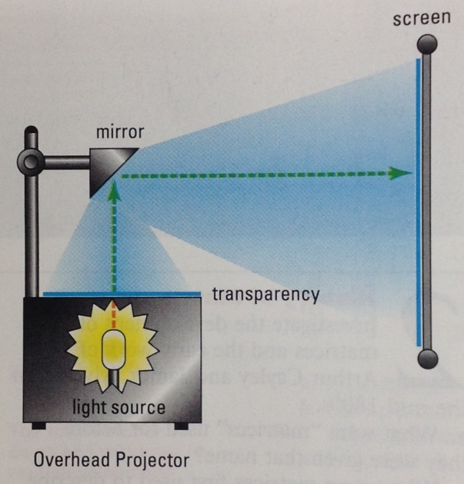
- CHALLENGE: Explain how the projector enlarges images using geometry?

