Algebra 1
Chapter 3: Addition in Algebra
3.8: Writing Linear Expressions – Tiling Tasks

Pacing: 1 day

Materials: -Algebra tiles for overhead, Student Tiling worksheet

Objectives: -Write expressions and solve problems involving linear patterns with two variables.

Lesson:
Begin class with the following task:

Alfredo Gomez is designing patios. Each patio has a rectangular garden area in the center. Alfredo uses black tiles to represent the soil of the garden. Around each garden, he designs a border of white tiles. The pictures shown be-low show the three smallest patios that he can design with black tiles for the garden and white tiles for the border.
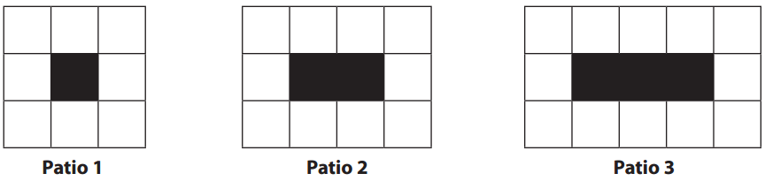
- Draw patio 4 and patio 5. How many white tiles are in patio 4? Patio 5?
- Make some observations about the patios that could help you describe larger patios.
- Describe a method for finding the total number of white tiles needed for patio 50 (without constructing it).
- Write a rule that could be used to determine the number of white tiles needed for any patio. Explain how your rule relates to the visual representation of the patio.
- Write a different rule that could be used to determine the number of white tiles needed for any patio.
Explain how your rule relates to the visual representation of the patio.

After a class discussion and students are able to generalize the pattern using variables and equations, intro the Tiling a Cafeteria ACT 3 task.

Let’s say our school is looking to replace the cafeteria flooring with new tile flooring. Our principal wants it too look nice and is looking a checker pattern on the outside edge:
Show file “1 Full Cafeteria -100th iteration”

Make a guess about how many dark color tiles there are. Try making a guess you know is too high and a guess you know is too low.

I know in a pinch you could count the number of tiles but that takes a lot of work. In order to try and save ourselves some work, we’re going to look at some smaller floor plans and see if we can find any ways to figure out the bigger question.

Have students work on finding the number of tiles in the first 4 iterations (on back of previous worksheet).

Now see if you can find the number of dark color tiles in the 20th iteration.
(Show the number on the screen, file: “3 20th iteration”

Let’s go back to the original question. The square we looked at is the 100th iteration of this pattern. Can you find the number of tiles?

Let’s add one more thing. If we’re going to tile the cafeteria, it costs money. How much money would it cost if:

Costs for Tile flooring:
$3.19/Sq. Ft. for lighter tiles.
$3.45/Sq. Ft. for Darker tiles

