A soup company wants to break into the market in Boulder. Unfortunately, it takes effort to get someone to notice your new product. In an attempt to attract attention, they’ve decided to use irregular packaging. They decide to package six cans in a box in the shape of an equilateral triangle. The radius of each can is 4 cm and the height is 11 cm.
They’ve hired our firm to design the box.
- Find the length of a side of the package (i.e. find the length of $\overline{JH}$).

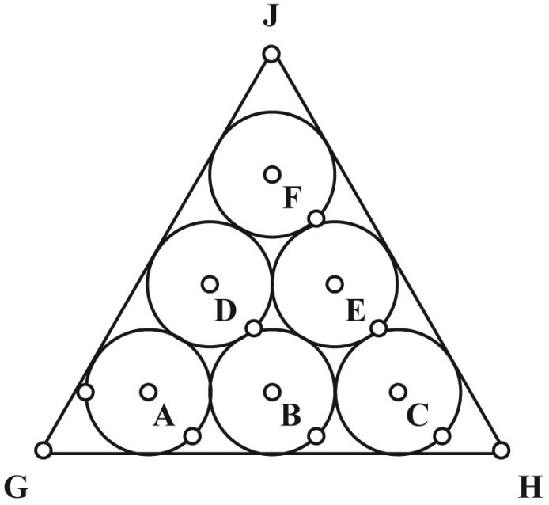

- Make a drawing of the unfolded soup box (the net). Be sure to include dimensions in your drawing for our engineering department.

- Without thinking how we will join the seams of our package, what is the minimum amount of cardboard we will need for each package? Be sure to document your thinking process; engineers get cranky when they think you’ve made up numbers and they’ll have to redo your work.

- In order to join pieces of cardboard together, we will need tabs which will give us room to glue the pieces together. Based on the weight of the box, the tabs will:
- run the entire length of a side,
- extend out 1cm past the side of the box,
- need to be on every edge of the finished package which does not include a fold. (1 tab per edge)
Sketch a new net of our soup box with your ideas of where we need to include tabs.

- How much cardboard will we need for each soup box?

The soup company is concerned about the box corners breaking or deforming during shipping or stacking on the shelves. Since people don’t tend to purchase items in broken boxes, they want to know what it would look like if we changed the packaging. They want us to include a design which has rounded corners following the curvature of the soup can rather than going to a point past the soup cans. For example, in the drawing, the gray corners would no longer be part of the packaging.

Without thinking about how we will join the seams of our package (i.e. ignore tabs like in #3):
- Draw a net of the new situation. Be sure to include dimensions in your drawing for our engineering department.

- How much cardboard would the soup manufacturer save per container if we went with this design?

