Notes for Reading and Understanding
Several universities offer degrees in packaging. Designing packages is interesting and complex. Package designers must consider many things including choice of material, cost, post-use recycling, shipping and distribution, and design appeal.
Packaging engineers draw patterns, or nets, that can be folded to form packages. A net is a two-dimensional pattern that can be folded to form a three-dimensional figure. These patterns help determine the amount of material needed to construct the packages.

The diagram below shows one possible net being folded into a three-dimensional cube.

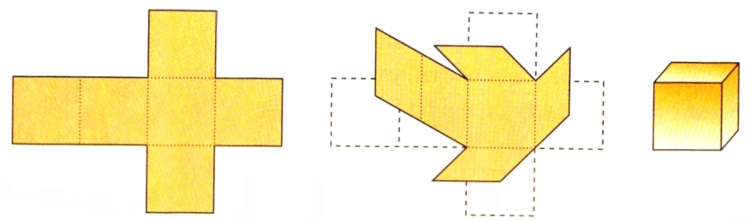

The three-dimensional shape above is called a unit cube because all of its edges are 1 unit long. The cube is also an example of a rectangular prism.

• How many faces does this cube have? How many edges?

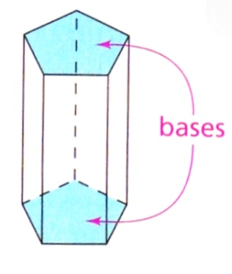
A prism is a three-dimensional shape with two parallel and congruent faces called bases. The other faces are called lateral (side) faces and are parallelograms.

A rectangular prism has bases that are rectangles. The length and width of a rectangular prism are the length and width of its rectangular base. The height is the distance from the bottom of the prism to its top. The length, width, and height of a rectangular prism are its dimensions.
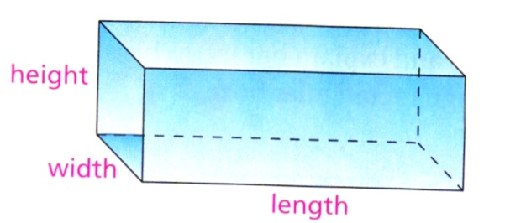

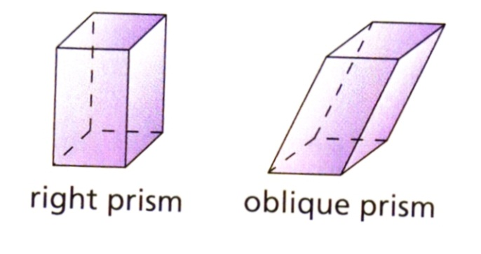
In a right prism, the lateral faces are rectangles. In an oblique prism, the lateral faces are nonrectangular. In this Activity, you may assume that a prism is a right prism unless stated or pictured otherwise.

The surface area of a box is the total area of all its faces.

- What is the total surface area of a unit cube?

In this Investigation, you will experiment with various three-dimensional shapes made from two-dimensional nets.

The most common type of package is the rectangular box. Rectangular boxes hold everything from cereal to shoes to pizza to paper clips. Most rectangular boxes begin as flat sheets of cardboard, which are cut and then folded into a box shape.

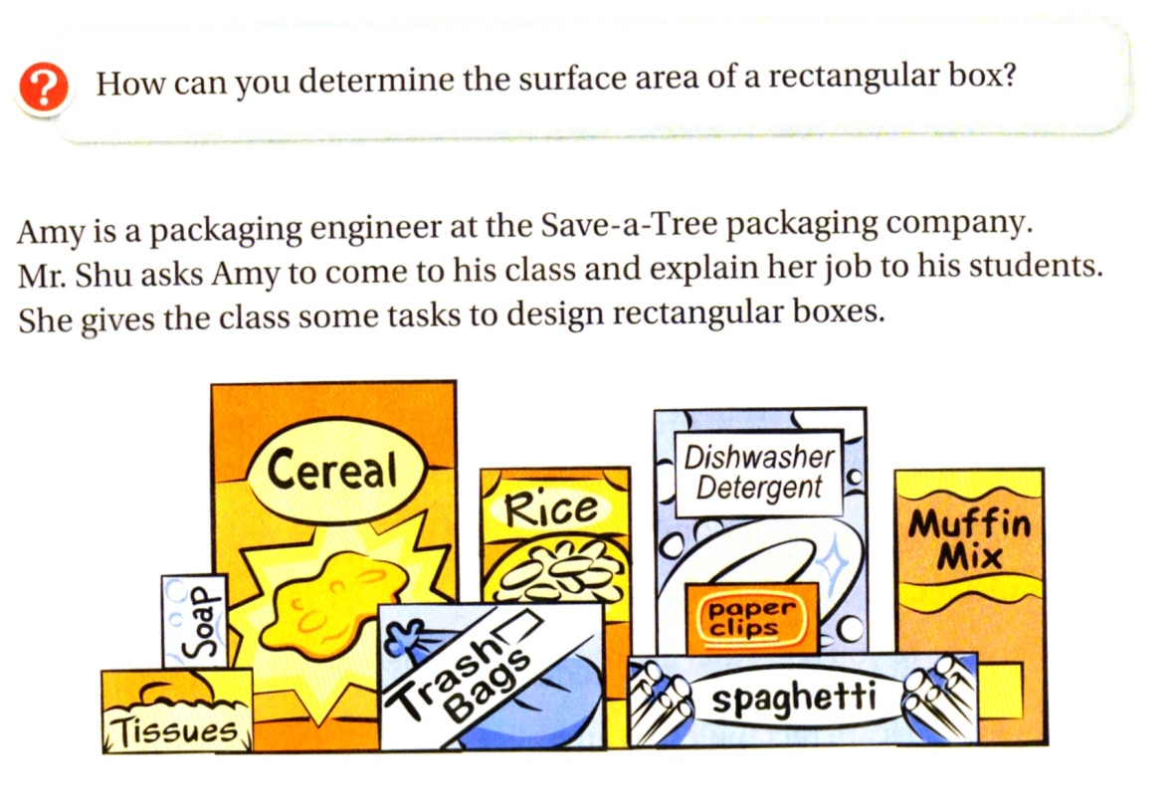

A. On grid paper, draw three different nets that will fold into a box shaped like a unit cube.
- What is the total area of each net, in square units?

- Design a net that forms any other rectangular prism. Draw on Grid Paper

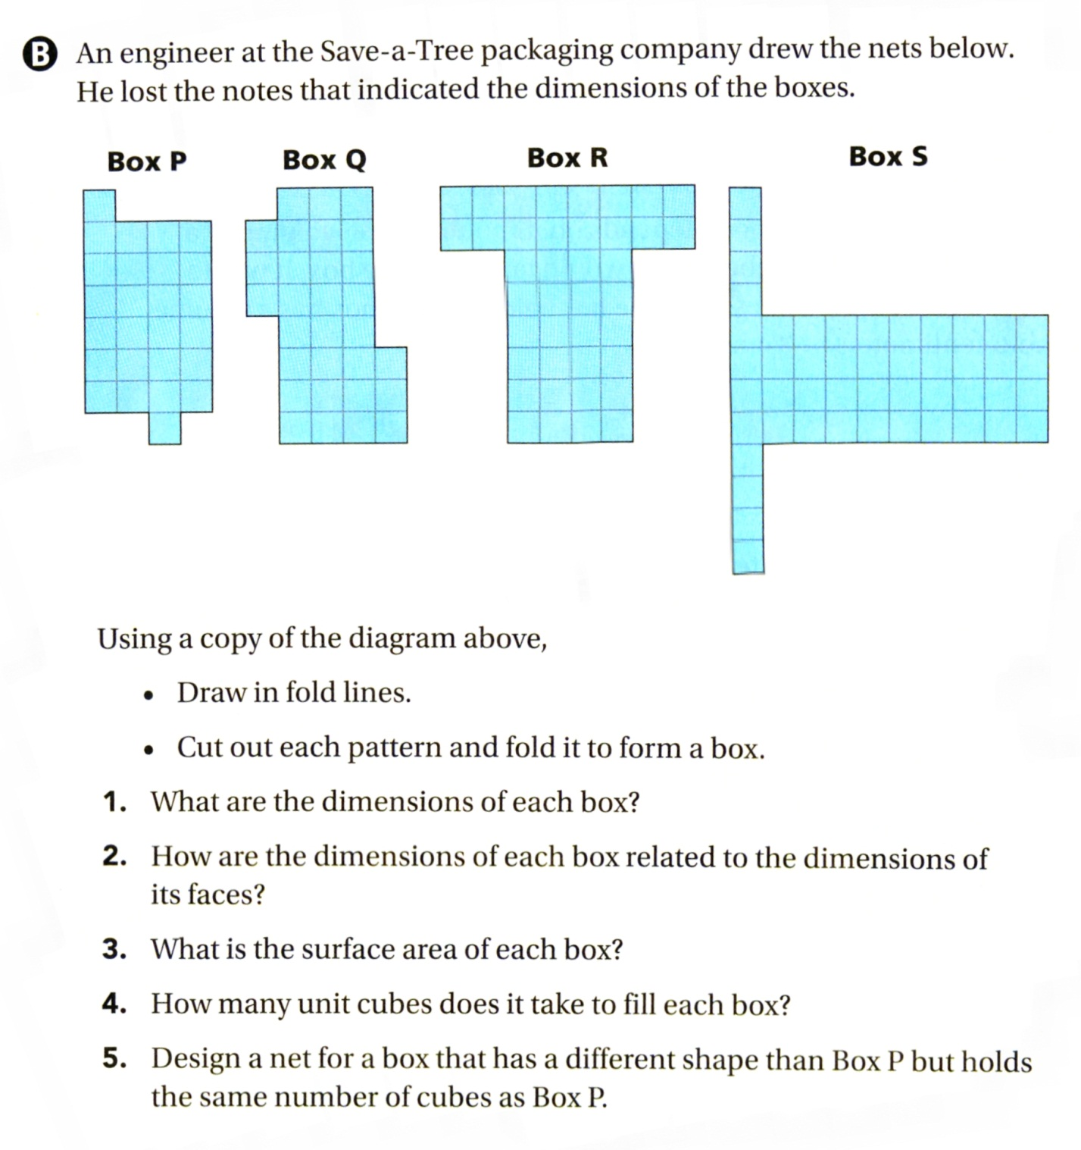

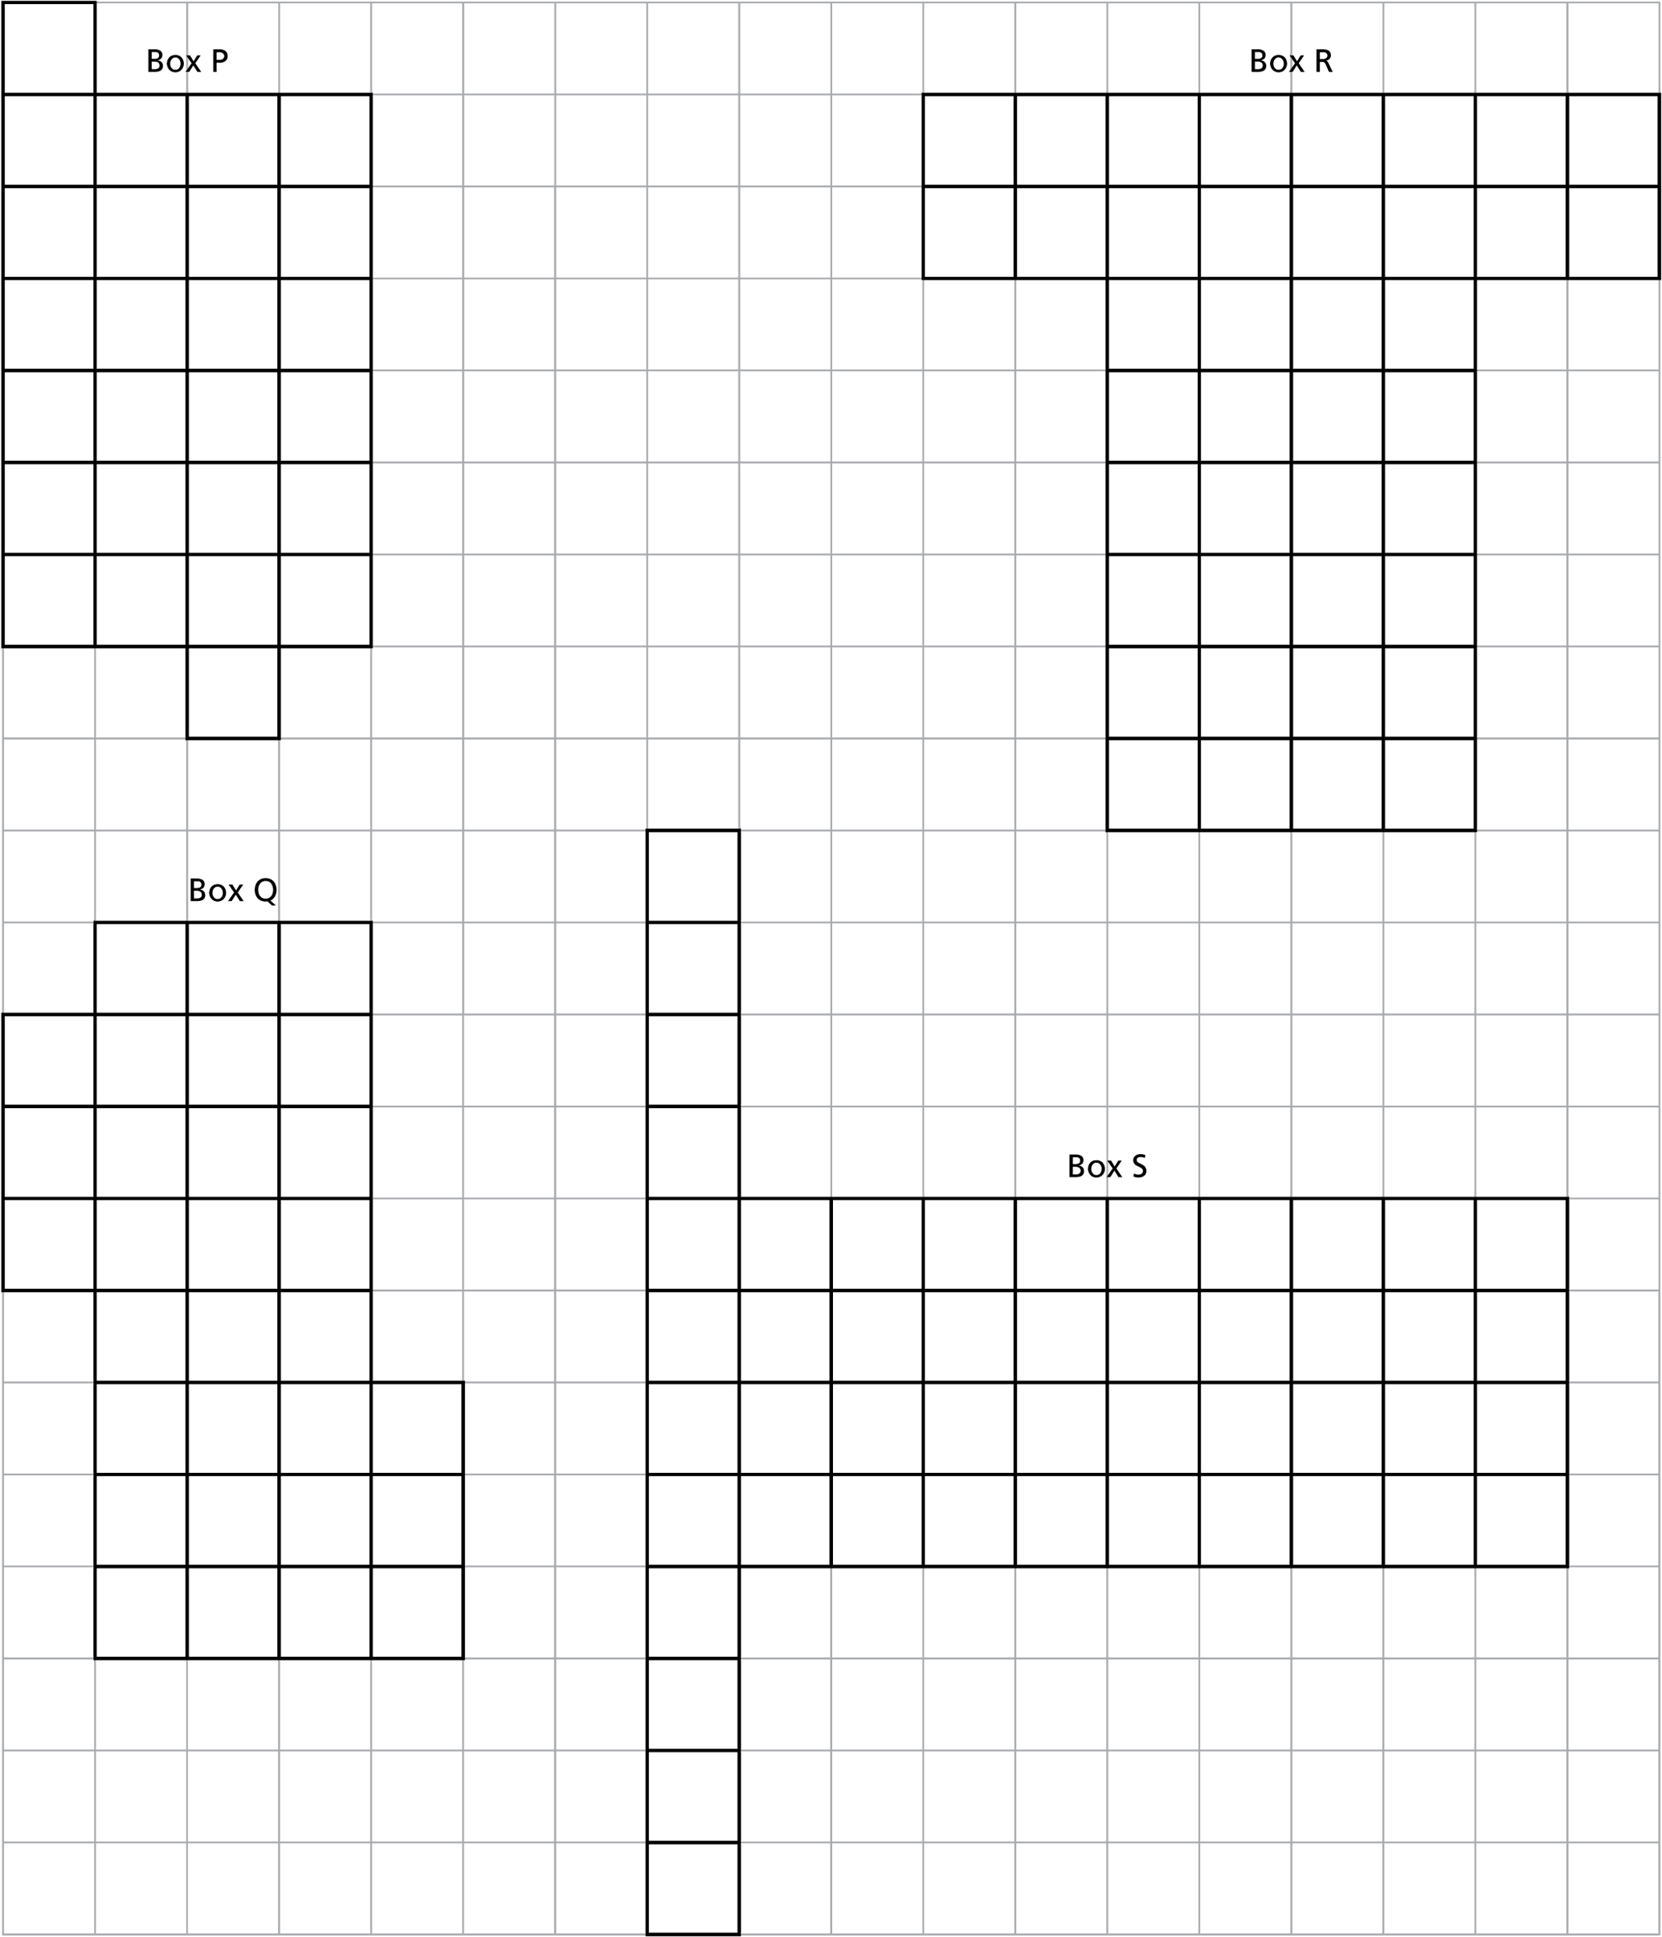
Box Nets

