1. Based on the video:
   1. Write down a guess for how many pennies will fit inside the carpet circle.
   2. Write down a number you think is too high.
   3. Write down a number you think is too low.
2. For each circle, place as many pennies as you can in a single layer inside the circle. Each of the circles increases in diameter by 1 inch. Work together to try to place as many pennies as possible. Count the pennies and record your data.

|  |  |  |  |  |  |  |  |
| --- | --- | --- | --- | --- | --- | --- | --- |
| **Diameter of Circle (in inches)** | 0 | 1 | 2 | 3 | 4 | 5 | 6 |
| **Number of Pennies** | 0 | 1 |  |  |  |  |  |

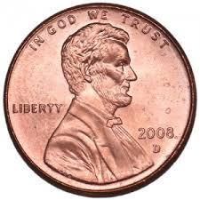

1. Graph the data in the table using the grid. Be sure to label the axes. Connect the points with a smooth curve.



1. What type of equation best models the data: linear, exponential, or quadratic? How do you know?
2. Based on your answer to question 4, find an equation which models the data well. Be sure to explain your thinking--I want you to understand how you came to your decision. Check your work using a graphing calculator or DESMOS.
3. You now have enough information to predict the number of pennies in the carpet circle. Good luck! (We’ll reveal the answer once everyone is ready.)
4. Okay, this next question is really just curiosity running wild. How big is the smallest circle that would enclose 2,000 pennies?
5. How many pennies lie along the circumference of the big circle? Do you think that model will be quadratic also? Convince me.