Alfredo Gomez is designing patios. Each patio has a rectangular garden area in the center. Alfredo uses black tiles to represent the soil of the garden. Around each garden, he designs a border of white tiles. The pictures shown below show the three smallest patios that he can design with black tiles for the garden and white tiles for the border.
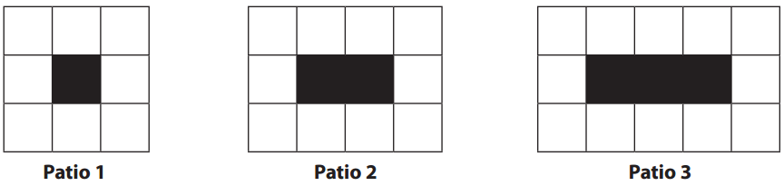
- Draw patio 4 and patio 5. How many white tiles are in patio 4? Patio 5?

- Make some observations about the patios that could help you describe larger patios.

- Describe a method for finding the total number of white tiles needed for patio 50 (without constructing it).

- Write a rule/equation that could be used to determine the number of white tiles needed for any patio. Explain how your rule relates to the visual representation of the patio.

- Try to come up with a different rule that could be used to determine the number of white tiles needed for any patio. Explain how your rule relates to the visual representation of the patio.

