Levers
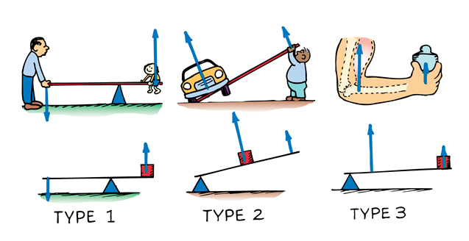
Materials Needed:
2 metersticks, hook weight, base and attachments for meterstick lever
For EACH type of lever above:
- Create the lever. Vary the distance of the fulcrum to the load (3 or 4 times). For each distance, measure the amount of input force it takes to move the load. Measure the distance of the input force and distance the weight moves.
- Calculate the amount of work done for each distance from the fulcrum.
- Calculate the amount of input force required to do that much work. How does it match your measured forces?
- Calculate the mechanical advantage of each distance from the fulcrum.
- Is there an optimal placement of the fulcrum for each of the types of levers?

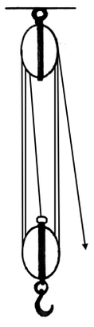
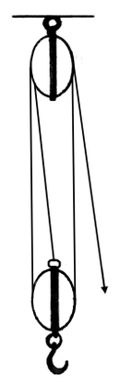
Pulley Systems – Block and Tackle
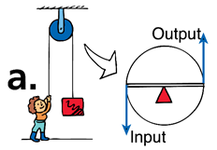
c.
b.

Materials Needed:
2 boards with rings and hooks for attaching pulleys, 2 c-clamps, pulleys, hook weight, spool of string (do not cut this!), spring scale.
Pulley Systems:
- Create the pulley system in diagram A. Use a pulley with 4 wheels for the top.
  - Measure the force required to raise the weight.
  - Measure the distance the weight travels.
  - Measure the amount of string used to pull the weight (start at the pulley)
- Create the next pulley system (diagram B). Use a pulley with 3 wheels for the bottom pulley. Repeat all 3 measurements done with the 1st pulley system.
- Create the next pulley system by stringing the rope through the bottom and top pulleys again (diagram C). There should be 5 wheels total. Repeat all 3 measurements done with the previous pulley systems.
- Create the next pulley system by stringing through the bottom and the top again (7 wheels total). Repeat all 3 measurements done with the previous pulley systems.
- For each pulley system, calculate the amount of input force required to do that much work. How does it match your measured forces?
- Calculate the mechanical advantage of each pulley system you created.
- What is the relationship between the number of bottom pulleys, the amount of input force required, and the amount of string used?
- Make an estimate for the input force for a system of 9 pulleys.
Ramps (Inclined Planes)
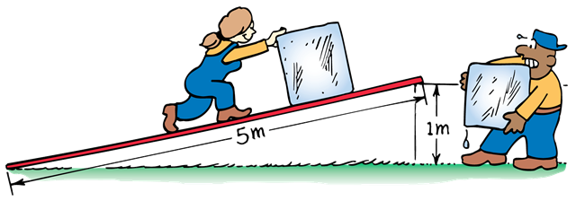
Materials Needed:
Board or metal ramp, protractor, piece of string, washer, cart, weight, spring scale, tape measure, maybe some tape.
Ramps:
For a constant height (your choice) vary the angle and distance of a ramp.
- Using the spring scale and your tape measure, measure the amount of force and calculate the amount of work it takes to raise your loaded cart to your desired height.
- Use the full length of the ramp for your chosen height. Use the protractor with the string and washer attached to find the angle of inclination. Now measure the amount of force needed to pull the loaded cart up the ramp.
- You will need to increase the angle of inclination 3 times. Pick a number that works well for your increase (15 degrees could work). Increase the angle of the ramp by your chosen amount. Measure the distance of the ramp up to the constant height. Measure the amount of force needed to pull the loaded cart up the ramp.
- Increase the angle of the ramp (2nd time). Measure the distance of the ramp up to the constant height. Measure the amount of force needed to pull the loaded cart up the ramp.
- Increase the angle of the ramp (3rd time). Measure the distance of the ramp up to the constant height. Measure the amount of force needed to pull the loaded cart up the ramp.
- Calculate the amount of force it takes for each of your 5 previous experiments. How does this compare with your measured amounts?
- Calculate the mechanical advantage of each ramp angle.
- Is there a significant change between angles? Is the change constant?

