Geometry
17f: The Cosine Ferris Wheel

CCSS for Math Content
F-BF: Build a function that models a relationship between two quantities.
Build new functions from existing functions.
F-TF Model periodic phenomena with trigonometric functions.
CCSS for Math Practice:
4. Model with mathematics
7. Look for and make use of structure.

Lesson:
[Based on “Ferris Wheel” from the Mathematics Assessment Resource Servcies: University of Nottingham and UC Berkeley – Beta Version]
http://map.mathshell.org/materials/lessons.php?taskid=427&subpage=concept
[Students will need mini whiteboards and markers]
Today, we’re going to venture deeper into our trigonometric functions focusing specifically on graphing them.
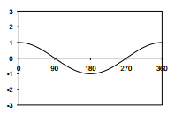
On your mini-whiteboards, sketch the graph y = cos x.
What is its maximum value? [1]
What is the minimum value? [-1]
What is the period of the cosine function?
[After 360º the function values repeat.]
Where does it cross the x-axis?

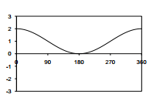
Now try y = 1 + cos x.
What is the maximum value? Minimum value? [2, 0]
What does adding the constant do to the
graph of y = cos x?
[Translates the graph +1 units vertically.]

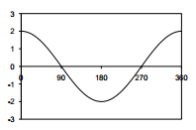
Graph y = 2cos x.
What is the maximum value? Minimum value? [2, -2]
Where does the graph cross the x-axis?
What does multiplying by a constant do to the graph of y = cos x?
[Stretch by factor of 2 parallel to y-axis.]
Has the period of the function changed? [No.]
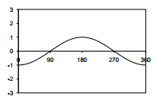

What about multiplying by -1? That gives y = - cos x.
[This reflects the graph in x-axis.]
Has the period of the function changed? [No.]

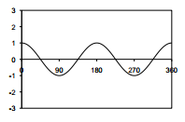
Show me y =cos 2x.
What does multiplying the x by a constant do to the graph?
[Stretch parallel to x-axis.]
Is the period of this function different?
[Yes. The period is now 180 degrees.]
Ask students to generalize how the period affects the function.
[y=cos(cx) where c = 360/period]

Try to combine some changes.
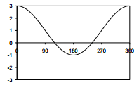
Show me y =1+2cos x.
What is the maximum value? Minimum value? [3, -1]
Where does this graph cross the x-axis? Estimate!
[120°, 240°]
What has happened to the graph of y = cos x?
[Stretched by a factor of 2 parallel to the y-axis, and translated +1 units vertically.]
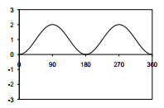
Now show me y =1 – cos2x.
What is the effect if you combine multiplying by -1, and multiplying the x by a constant?
[Stretch parallel to the x-axis, with a reflection of the graph in the x-axis.]

Matching Activity 1—Functions
[No calculators]
Hand out card set A: Graphs and card set B: Functions [1 set per pair of students]
In seat pairs, cut out the cards and match them together as best you can. Be sure to discuss your reasoning with each other. There is a blank card, keep it. If you cannot find an equation to match your graphs, then please make one up. It is possible that more than one equation will work for a graph.
Remember: the purpose of this task is for you to share your reasoning process for placing the cards with another human being NOT just correctly matching pairs.

Matching Activity 2—Descriptions
Give each pair of students a copy of Card Set C: Descriptions of the Wheels.
Directions:
Each of the functions you have been looking at models the motion of a Ferris wheel.
I now want you to try to match the correct wheel description to the graphs and functions on the table.
On these graphs the heights are given in meters and the times in seconds.

Some questions to ask students as they work:
How is the height of the axle related to the graph?
How is the speed of rotation related to the graph?
How is the diameter of the wheel related to the graph?
How is the height of the axle related to the algebraic function?
How is the speed of rotation related to the algebraic function?
How many degrees per second does this wheel turn through?
How is the diameter of the wheel related to the algebraic function?
Why do both these functions fit this graph?
Why do we have two graphs with the same description?
What is different about the graphs?

Formalizing the Content: [whole class discussion]
Ask students to come up with a general explanation of how to decide which function goes with which situation.
Suppose I wrote down the function h = a - b cos t. What can you tell me about the Ferris Wheel?
[Height of axle = a; diameter of wheel = 2b; turns once every 360 seconds.]
Suppose I wrote down the function h = a - b cos 2t. What can you tell me about the Ferris Wheel?
[Height of axle = a; diameter of wheel = 2b; turns once every 180 seconds.]

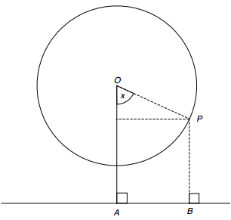
Use the picture to the right to help students explain the analytical connection between the geometry of the situation and the function h = a + -b*cos(ct).
The diagram shows the position of a rider, P, at some time during the ride.
Height of the axle = OA = a
Radius of the wheel = OP = b
At this time, suppose the ∠POA = x
As P goes round steadily, then x = c*t for some constant c.
(c = 1, wheel turns round once after 360 seconds; c = 2, wheel turns round once every 180 seconds, and so on. So c = 360/period)
The height of the rider
= PB
= OA + –OP cos(x)
So h = a + –b*cos(ct)

Height = height of axel + –radius*cos((360/period)*time)
The negative in front of the cosine function reflects it over the x-axis. This allows us to start at the bottom of the circle and then move around it. Adding the height of the axel

