Directions: Show all the associated work for each problem to receive full credit. All calculations should be brought out to AT LEAST the thousandths place.
Replace the image below with a screenshot of your DESMOS graph.
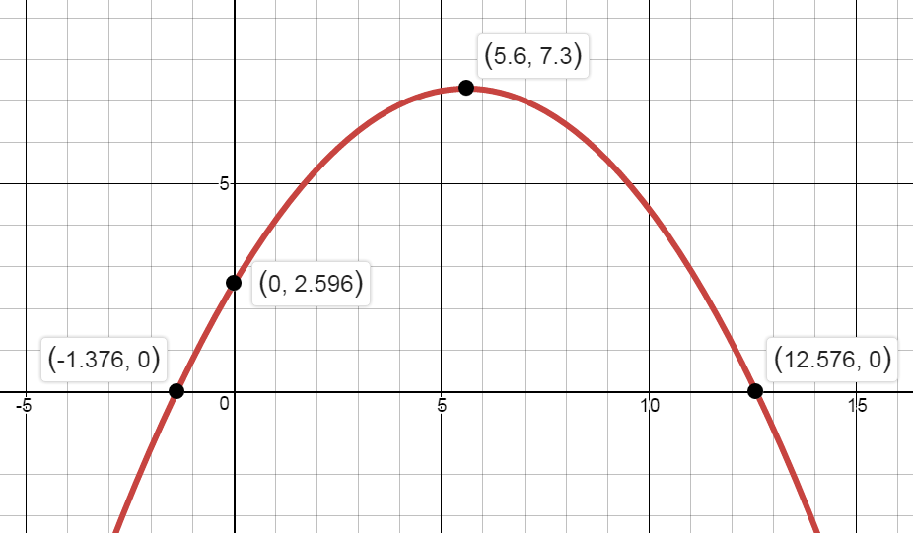
INSERT A COPY OF YOUR GRAPH HERE!

Given the above function, with vertex ( _____, _____ ), and a point ( _____, _____ ):
- Show me you know how to find the a-value for the vertex form of a quadratic equation.

- Write your function in vertex form.

- Using your function from #2, put your equation into standard form.

- Using the standard form of your function, convince me you know how to calculate the vertex from the equation.

- Convince me you know how to calculate the roots of the function algebraically (i.e. not graphically).

- Based on the work you’ve done so far, write your function in factored form.

